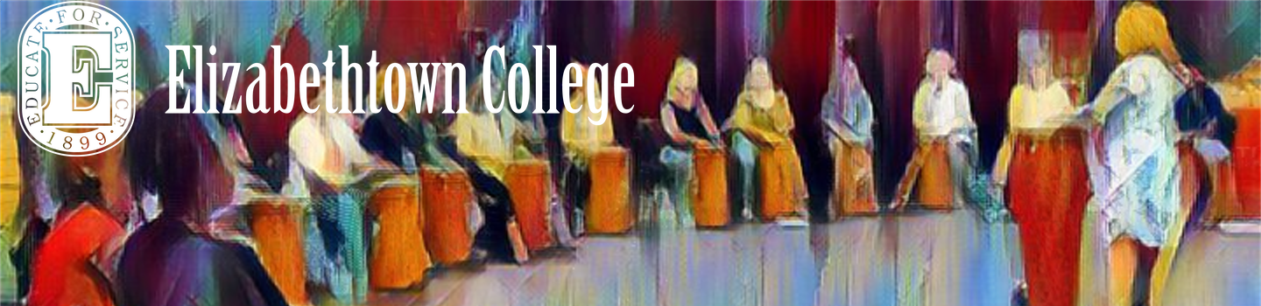

Trauma Notes
4/2/2020

Guest: Dr. Gene Behrens
Gene Ann Behrens, Ph.D., MT-BC is a professor and director of the music therapy program at Elizabethtown College. She has taught and supervised students for over 25 years and worked as a music therapist for 45 years in a variety of settings. She maintains an avid interest in teaching, supervising, and conducting research since her studies and work within a research institute during her PhD. She works to instill the joy of and need for research among her music therapy students who all conduct studies as part of the curriculum at Etown. She has published a chapter on statistical analysis using SPSS in Wheeler and Murphy’s (2016) Research in Music Therapy and an article on ethics in research (2020) in Music Therapy Perspectives.
Gene Ann’s research on music therapy and the neurobiology of trauma has led to national and international publications and presentations in several countries such as Australia, South Korea, Austria, Japan, and Argentina. More specifically, she was invited to speak for Penn State Hershey Medical Center; a NATO Security workshop in Ankara, Turkey; Mahatma Gandhi Medical College and Research Institute Campus, Pondicherry, India; and the music therapy school at ArtEZ University of the Arts in Enschede, Netherlands.

Neural Science of Trauma and Anxiety
“Trauma-informed” - nerual science approach to trauma-informed
\
Changing our perspective from:
A student being
“Out of control”
“Defiant”
“Can’t control self”
“Doesn’t care about anything”
“Is lazy”
“Has checked out”

These phrases all mean that the student is to blame. We are asking -- “what is wrong with the student”

Trauma causes dysfunctional networks in the brain, these kinds of changes are normal reactions to horrific experiences.
When a student is traumatized & responds to events:
We can refer to students as being “hijacked” by their nervous system”
These students respond to “activators” before they can begin to use any thoughts/coping skills to regulate behavior. (we choose to use “activator” instead of “trigger”)

For an adult who has dealt with complex trauma, research says that adult brains are significantly smaller because of trauma that has taken place.

Instead of thinking that the:
Student is to blame -> think that the “Nervous system is hijacked”
What is wrong with the student -> What happened to the student
Student can immediately change & control self - > How can I create a safe learning environment to help them co-regulate and help them regulate. Students need to co-regulate before they are able to regulate. To co-regulate means imitating and being in relationship in a way that develops regulation.

Introducing Polyvagal Theory, developed by Steve Porges (2018)
Recommended book -- The Polyvagal Theory in Therapy: Engaging the Rhythm of Regulation by Deb Dana

PART 1: Science behind the Nervous System - Talking about a “Socially Engaged Person”

Basics of the Nervous System (NS) (Anatomy 101)
The Vagal Nerve is one of the longest nerves in our body that moves from our face all the way into our digestive system. The vagal nerve operates in two parts (this is where polyvagal comes from)
- Central NS - brain and spinal chord (key components amygdala, thalamus, hippocampus)
- Peripheral NS - autonomic NS and somatic NS
Autonomic: Sympathetic Nervous System and Parasympathetic

Sympathetic is the Fight or Flight System

Parasympathetic has actually has two tracks:
Dorsal - diaphragm down — Withdrawn responses
Ventral - Newest system in evolutionary development, intervals in facial muscles, and a nerve that goes into your inner ear, these are known as the “social engagement responses”

Vagal break is the nerve break that inhibits us from going into the sympathetic nervous system. This enables us to smile, talk, interact, and learn. When we encounter an interruption (something that doesn’t feel safe), our vagal break allows us to return to our parasympathetic nervous system.

Interruption - when we encounter something that is unsafe, this flips us into the sympathetic nervous system.

Parasympathetic dorsal can be used to slow things down and recharge. The vagal break can be used to recharge and be able to interact with people again.

Neuroception - automatic processing of safety without cognitive mediation that hijacks the nervous system. It only takes a nanosecond for a person’s nervous system to be hijacked by the autonomic nervous system.

PART 2: Individuals with Challenged Nervous System - Dysregulated

An Anxious Child - When an interruption occurs (like changing the order of instruction or a fire drill) this is easily perceived as not safe, they head to the sympathetic system and stay there, to try to find ways to feel safe.

When Safety Needs are Not Met -
- Heart Rate
- Heart Rate Variability
- Stress Hormones
- Hyperarousal
- Fight or Flight Responses
- Communication Deficits

Symptoms in an anxious child when a nervous system is hijacked
- Constantly moving
- Escape behaviors
- Emotional outbursts
- Difficulty Expressing Self
- Problems organizing motor responses
- Difficulty with authority
- Unable to read people and contexts
- Difficulty concentrating
- Unable to hear and process information
- Difficulty learning
- Irritable

Over time, the body will drop responses from sympathetic into dorsal mode (parasympathetic
- Heart rate and respiration decrease
- Loose focus
- Becomes numb
- Dissasociation - mentally withdraws
- Limited ability to interact

Observed Symptoms Due to the Dorsal Nervous System (retreating system)
- Sit with head down
- Avoid eye contact
- Pull body in physically
- Avoid Talking
- Refrain from playing with others
- Not alert to sounds
- Unable to hear and process information
- Limited to no response to preferred items ( they won’t care about motivators)
- Limited to no emotional responses
- Become unresponsive

If the Ventral Mode is the place where we learn, how do we create safety to move into the Ventral Mode?

Science Behind Creating Safety
1) Observation - interpret symptoms: The Polyvagal approach helps us to hone our observation of students, to see student responses as symptoms of where a nervous system is operating
2) Creating Safety (need to calm/feel safe to learn): We need to prioritize building spaces of safety;
3) Challenge (if safe, challenge; if not create safety): Once we have created spaces of safety, we can provide challenges that support learning.

Creating Safety Strategies
- Teach deep breathing - teaching deep breathing facilitates a recentering of the nervous system
- Sing familiar songs
- Listen to music that calms
- Perform repetitive hand clapping patterns
- Perform lummi stick patterns
- Bounce on balls
- Monitor teacher proximity
- Use rhythmic voice
- Provide predictability
- Break tasks into small part
- Empower children
- Unconditional positive regard
- Maintain expectations
- Guide responses
- Support relationships
- Support coping skills
- Learn activators and avoid
- Offer choice/decision
- Involve rituals

How to offer challenge, what does it mean to challenge
- Add small steps;
- Teaching sequences
- Provide Imitation tasks
- Rehearse directions
- Add complexity
- Problem-solving tasks
- Interacting with other students
- Layer multisensory inputs
- Calling on individuals to respond vs. group

Concluding Comments -
A Neural Perspective to Trauma can help us observe and interpret, create safe learning experiences, and how we move to challenge learning.

Elizabethtown College
Offering a Master of Music Education Degree @ www.etown.edu/musicmasters
Our professional development Network is @ www.musicpeacebuilding.com

Join us for a Virtual Information Session on Monday, April 6th at 2:00 pm eastern:

Dr. Kevin Shorner-Johnson and the admissions team will be answering questions on COVID-19 flexibility, the admissions process, and Master's program coursework and answer any questions you have about the MME program or Elizabethtown College. Click Below to register!
https://www.etown.edu/scps/success/my-future.aspx

